Tangent
# Source: AI Source: Provided by: [Data Path: Persons Table -> ID Column: 1, Name_En Column: Motasem Essam] -> From: [ChatGPT] on [7/25/2026]
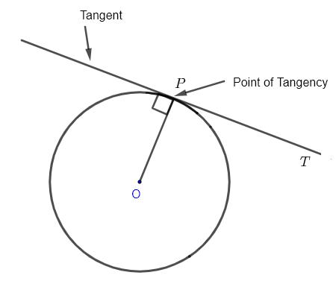
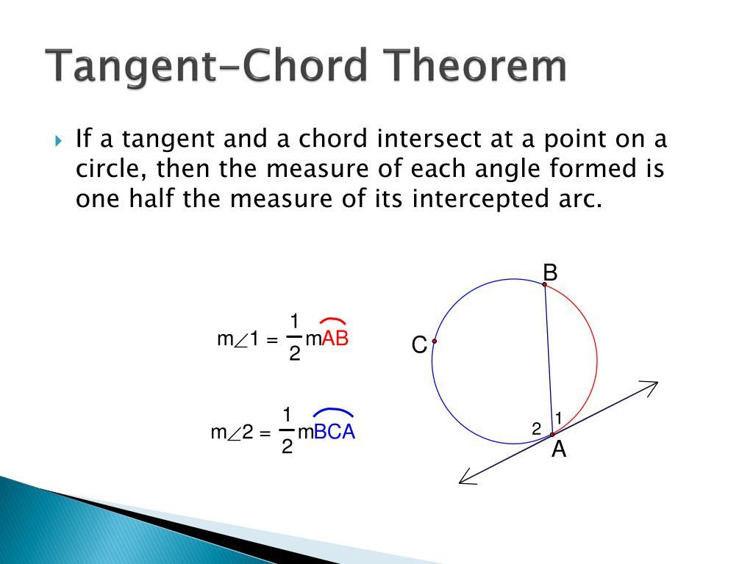
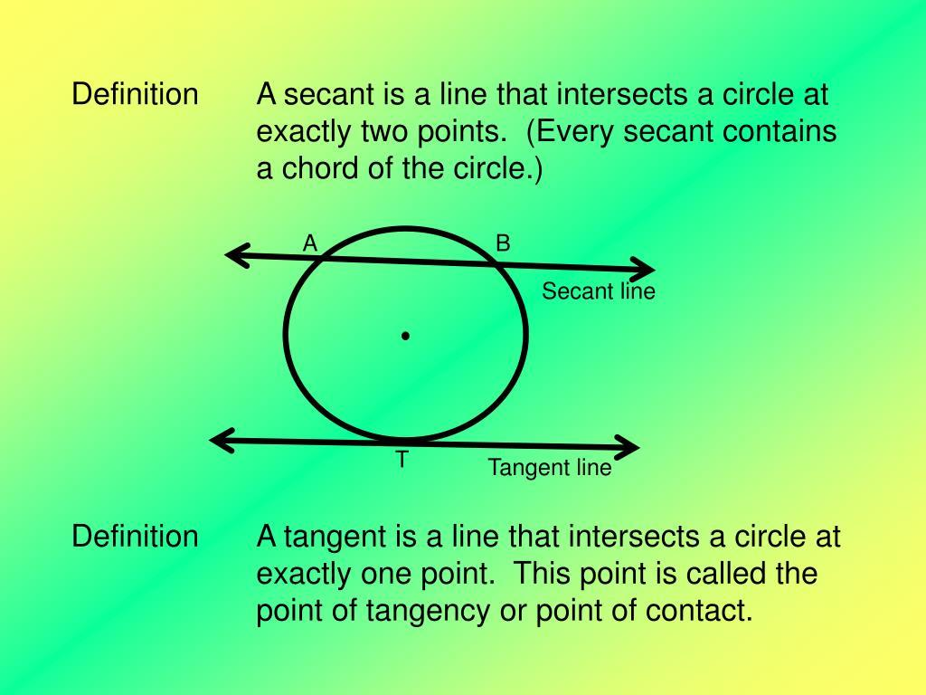
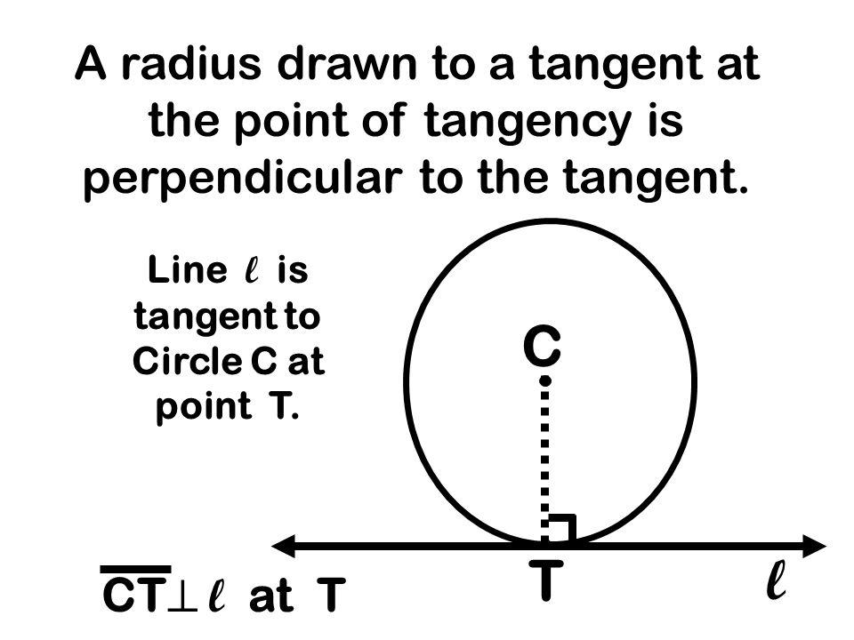

Definition
# Source: AI Source: Provided by: [Data Path: Persons Table -> ID Column: 1, Name_En Column: Motasem Essam] -> From: [ChatGPT] on [7/25/2026]
A Tangent is a line that touches a circle at exactly one point.
The point where the tangent touches the circle is called the Point of Tangency or Point of Contact.
If line $l$touches a circle with center $O$at $A$, then $l$is tangent to the circle at $A$.

Fundamental Concept
# Source: AI Source: Provided by: [Data Path: Persons Table -> ID Column: 1, Name_En Column: Motasem Essam] -> From: [ChatGPT] on [7/25/2026]
Consider a circle with center $O$and a tangent line $l$:
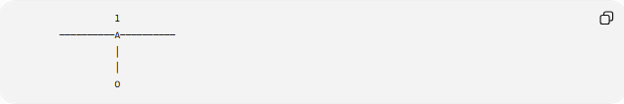
l
──────────A──────────
│
│
O
Here:
- $O$= center of the circle
- $A$= point of tangency
- $l$= tangent line
- $\overset{‾}{OA}$= radius
The most important relationship is:
$$\boxed{OA⊥l}$$
Therefore, the radius drawn to the point of tangency is perpendicular to the tangent.

Main Parts
# Source: AI Source: Provided by: [Data Path: Persons Table -> ID Column: 1, Name_En Column: Motasem Essam] -> From: [ChatGPT] on [7/25/2026]
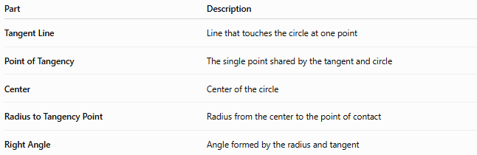
Part | Description
Tangent Line | Line that touches the circle at one point
Point of Tangency | The single point shared by the tangent and circle
Center | Center of the circle
Radius to Tangency Point | Radius from the center to the point of contact
Right Angle | Angle formed by the radius and tangent

Point of Tangency
# Source: AI Source: Provided by: [Data Path: Persons Table -> ID Column: 1, Name_En Column: Motasem Essam] -> From: [ChatGPT] on [7/25/2026]
The Point of Tangency is the unique point where the tangent line and circle meet.
If $l$is tangent to the circle at $A$:
$$\boxed{l∩\text{Circle}=\left\{A\right\}}$$
Unlike a secant, the tangent does not pass through the circle and intersect it at two points.

Radius–Tangent Theorem
# Source: AI Source: Provided by: [Data Path: Persons Table -> ID Column: 1, Name_En Column: Motasem Essam] -> From: [ChatGPT] on [7/25/2026]
The radius drawn to the point of tangency is perpendicular to the tangent.
$$\boxed{OA⊥l}$$
Therefore:
$$\boxed{∠OAl={90}^{∘}}$$
This is one of the fundamental theorems of tangents.

Tangent from an External Point
# Source: AI Source: Provided by: [Data Path: Persons Table -> ID Column: 1, Name_En Column: Motasem Essam] -> From: [ChatGPT] on [7/25/2026]
A point outside a circle can have tangents drawn to the circle.
If $P$is outside the circle and $PA$and $PB$are tangent segments:
$$\boxed{PA=PB}$$
Thus, tangent segments drawn from the same external point to a circle are congruent.
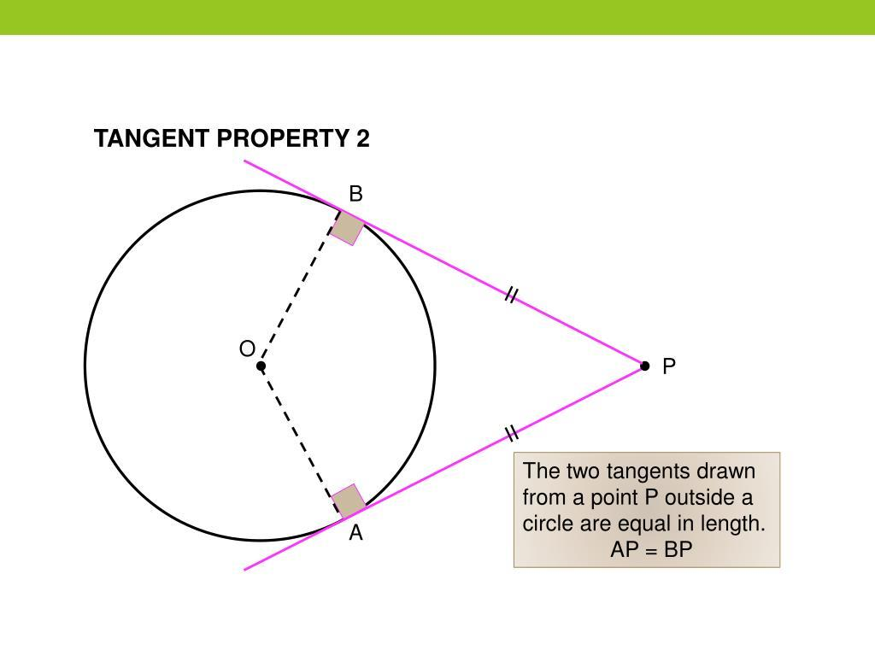
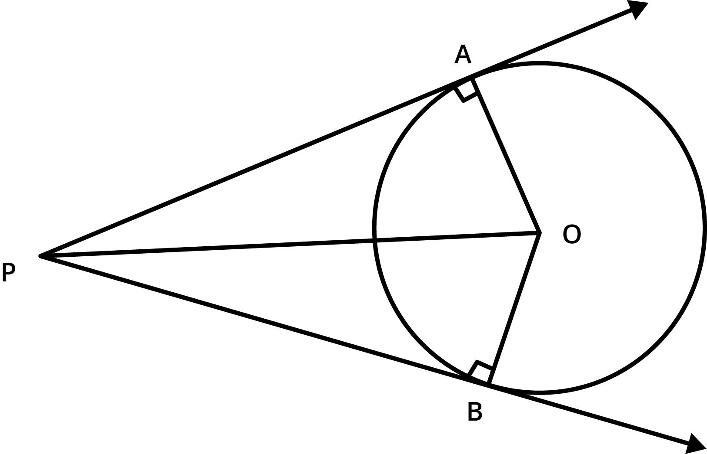
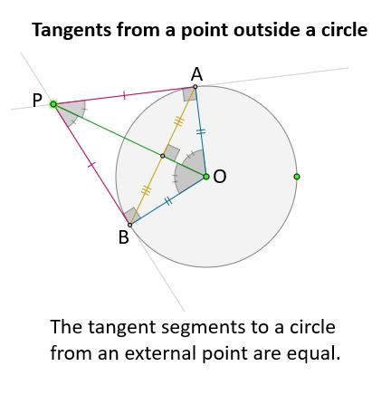
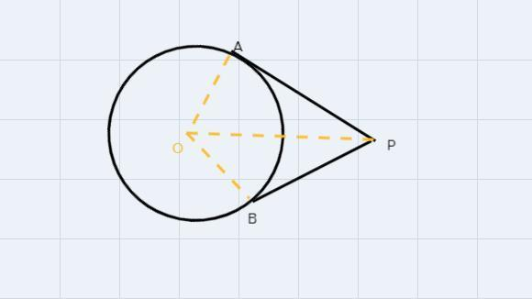
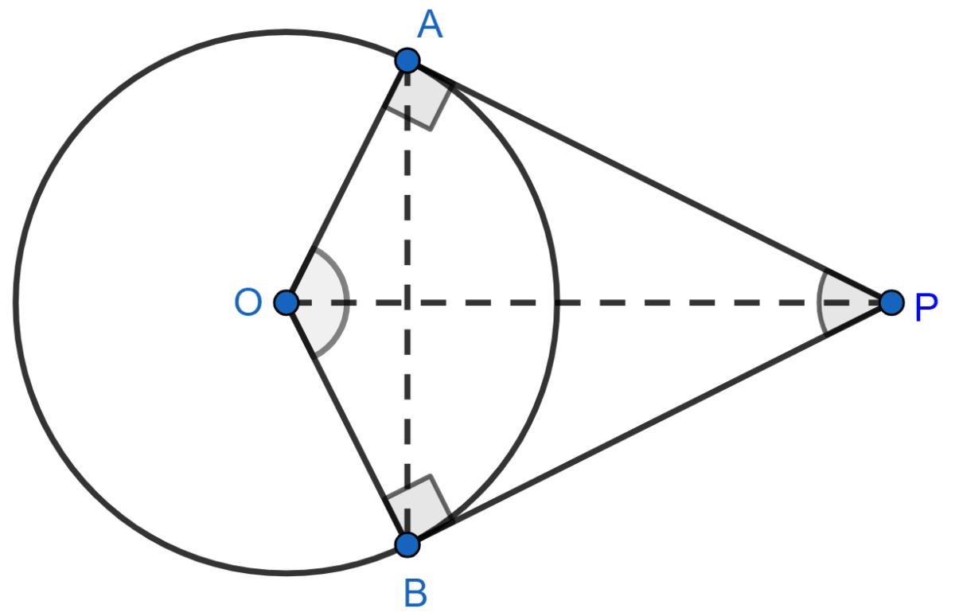

Number of Tangents from a Point
# Source: AI Source: Provided by: [Data Path: Persons Table -> ID Column: 1, Name_En Column: Motasem Essam] -> From: [ChatGPT] on [7/25/2026]
The number of tangents depends on the position of the point relative to the circle.
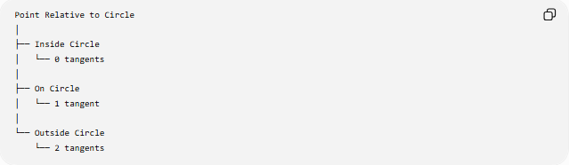
Point Relative to Circle
│
├── Inside Circle
│ └── 0 tangents
│
├── On Circle
│ └── 1 tangent
│
└── Outside Circle
└── 2 tangents
Point Inside
No real tangent can be drawn from a point inside the circle.
Point on Circle
Exactly one tangent can be drawn at that point.
Point Outside
Exactly two tangent lines can be drawn to the circle.

Tangent and Radius
# Source: AI Source: Provided by: [Data Path: Persons Table -> ID Column: 1, Name_En Column: Motasem Essam] -> From: [ChatGPT] on [7/25/2026]
For a tangent at $A$:
$$OA=r$$
and:
$$OA⊥l$$
Therefore, the tangent forms a ${90}^{∘}$angle with the radius.

Tangent–Chord Theorem
# Source: AI Source: Provided by: [Data Path: Persons Table -> ID Column: 1, Name_En Column: Motasem Essam] -> From: [ChatGPT] on [7/25/2026]
The angle between a tangent and a chord equals the angle in the alternate segment subtended by that chord.
If a tangent touches the circle at $A$and $\overset{‾}{AB}$is a chord:
$$\boxed{m\left(∠\text{tangent-chord}\right)=m\left(∠ACB\right)}$$
where $∠ACB$is an inscribed angle subtending chord $AB$.
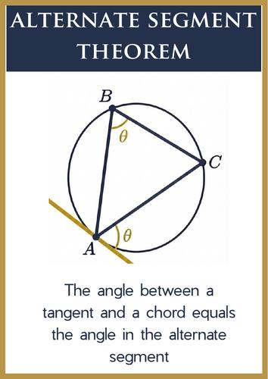
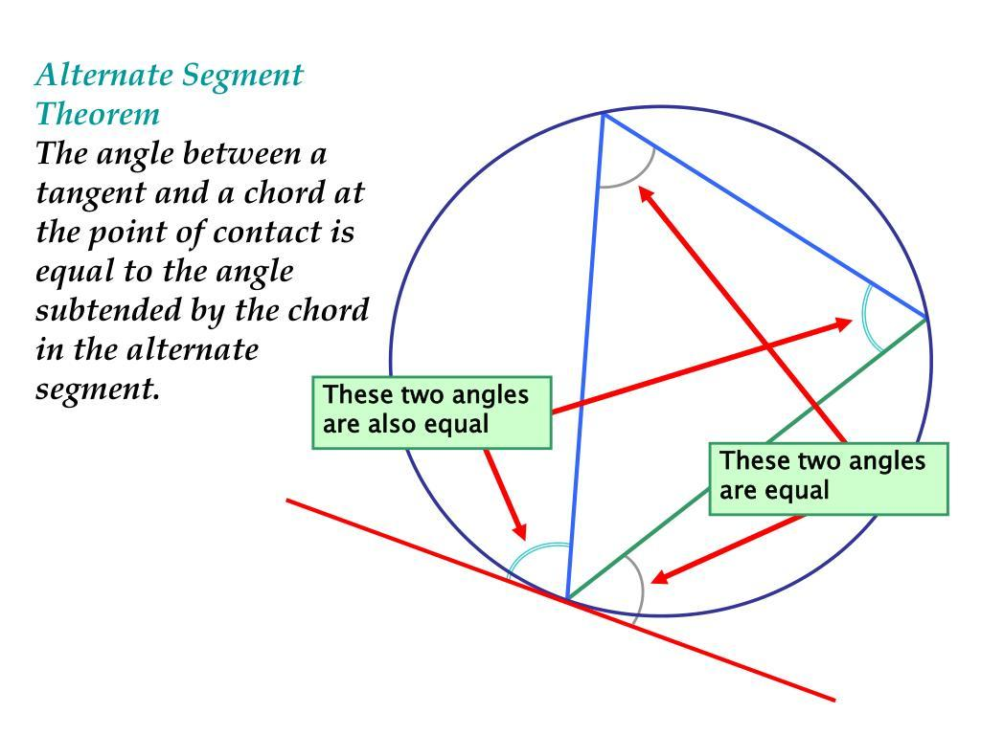
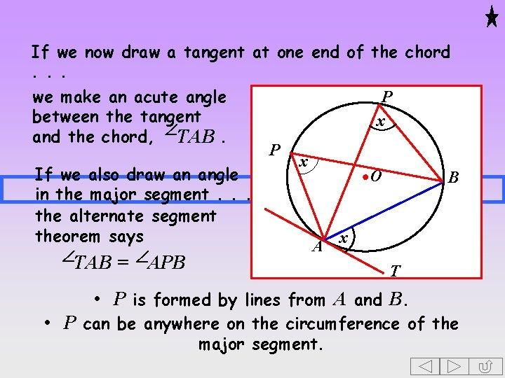
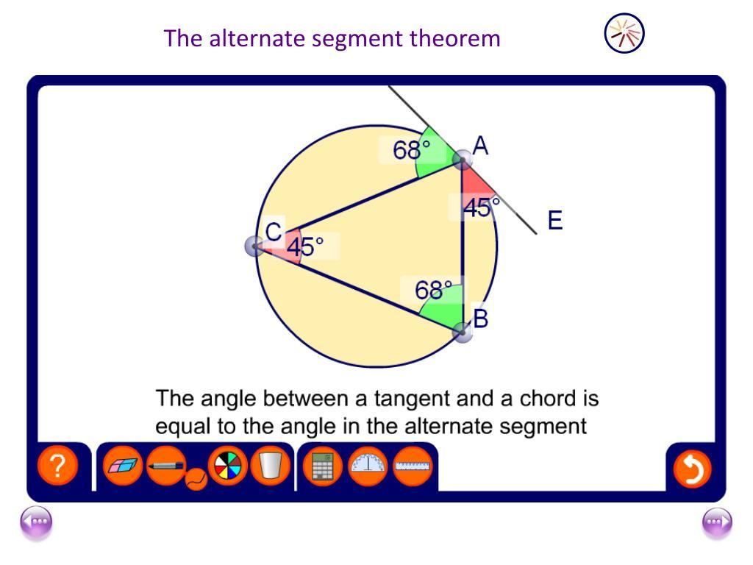

Tangent–Secant Relationship
# Source: AI Source: Provided by: [Data Path: Persons Table -> ID Column: 1, Name_En Column: Motasem Essam] -> From: [ChatGPT] on [7/25/2026]
A tangent and a secant can both be drawn from an external point.
The Tangent–Secant Theorem states:
$$\boxed{PT^{2}=PA⋅PB}$$
where:
- $PT$= tangent segment
- $PA$= external part of the secant
- $PB$= entire secant
This relationship is used to calculate unknown lengths.

Example of Tangent–Secant Theorem
# Source: AI Source: Provided by: [Data Path: Persons Table -> ID Column: 1, Name_En Column: Motasem Essam] -> From: [ChatGPT] on [7/25/2026]
Suppose:
$$PA=4$$
and:
$$PB=16$$
Then:
$$PT^{2}=PA⋅PB \\ PT^{2}=4\left(16\right) \\ PT^{2}=64$$
Therefore:
$$\boxed{PT=8}$$

Tangent–Tangent Theorem
# Source: AI Source: Provided by: [Data Path: Persons Table -> ID Column: 1, Name_En Column: Motasem Essam] -> From: [ChatGPT] on [7/25/2026]
When two tangents are drawn from the same external point:
$$\boxed{PA=PB}$$
For example, if:
$$PA=12\text{ cm}$$
then:
$$PB=12\text{ cm}$$

Tangent and Central Angle
# Source: AI Source: Provided by: [Data Path: Persons Table -> ID Column: 1, Name_En Column: Motasem Essam] -> From: [ChatGPT] on [7/25/2026]
The radius to the point of tangency is perpendicular to the tangent.
Therefore, the angle between:
- radius $OA$
- tangent $l$
is:
$$\boxed{{90}^{∘}}$$
The tangent itself does not pass through the center.

Tangent and Secant
# Source: AI Source: Provided by: [Data Path: Persons Table -> ID Column: 1, Name_En Column: Motasem Essam] -> From: [ChatGPT] on [7/25/2026]
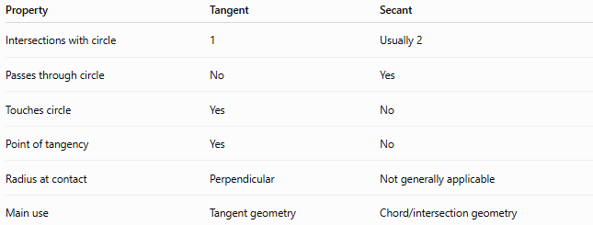
Property | Tangent | Secant
Intersections with circle | 1 | Usually 2
Passes through circle | No | Yes
Touches circle | Yes | No
Point of tangency | Yes | No
Radius at contact | Perpendicular | Not generally applicable
Main use | Tangent geometry | Chord/intersection geometry

Tangent vs Chord
# Source: AI Source: Provided by: [Data Path: Persons Table -> ID Column: 1, Name_En Column: Motasem Essam] -> From: [ChatGPT] on [7/25/2026]
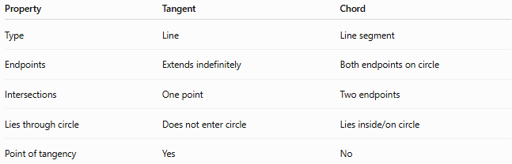
Property | Tangent | Chord
Type | Line | Line segment
Endpoints | Extends indefinitely | Both endpoints on circle
Intersections | One point | Two endpoints
Lies through circle | Does not enter circle | Lies inside/on circle
Point of tangency | Yes | No
A tangent and a chord can meet at the point of tangency.

Tangent vs Secant
# Source: AI Source: Provided by: [Data Path: Persons Table -> ID Column: 1, Name_En Column: Motasem Essam] -> From: [ChatGPT] on [7/25/2026]
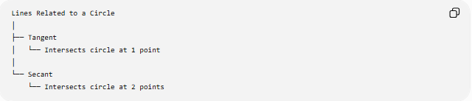
Lines Related to a Circle
│
├── Tangent
│ └── Intersects circle at 1 point
│
└── Secant
└── Intersects circle at 2 points
A tangent can be viewed as the limiting case of a secant as its two intersection points approach one another.

Tangent in Coordinate Geometry
# Source: AI Source: Provided by: [Data Path: Persons Table -> ID Column: 1, Name_En Column: Motasem Essam] -> From: [ChatGPT] on [7/25/2026]
For a circle centered at the origin:
$$x^{2}+y^{2}=r^{2}$$
the tangent at a point:
$$\left(x_{1} , y_{1}\right)$$
on the circle is:
$$\boxed{xx_{1}+yy_{1}=r^{2}}$$
For a circle centered at $\left(h , k\right)$:
$${\left(x-h\right)}^{2}+{\left(y-k\right)}^{2}=r^{2}$$
the tangent at $\left(x_{1} , y_{1}\right)$can be written as:
$$\boxed{\left(x_{1}-h\right)\left(x-h\right)+\left(y_{1}-k\right)\left(y-k\right)=r^{2}}$$

Tangent Length from an External Point
# Source: AI Source: Provided by: [Data Path: Persons Table -> ID Column: 1, Name_En Column: Motasem Essam] -> From: [ChatGPT] on [7/25/2026]
If $P$is outside a circle with center $O$, and $PA$is tangent at $A$, then triangle $OAP$is a right triangle.
Therefore, by the Pythagorean theorem:
$$OP^{2}=OA^{2}+PA^{2}$$
Since:
$$OA=r$$
we obtain:
$$\boxed{PA=\sqrt{OP^{2}-r^{2}}}$$
This gives the tangent length from an external point.

Example
# Source: AI Source: Provided by: [Data Path: Persons Table -> ID Column: 1, Name_En Column: Motasem Essam] -> From: [ChatGPT] on [7/25/2026]
Suppose:
$$OP=13\text{ cm}$$
and:
$$r=5\text{ cm}$$
Then:
$$PA=\sqrt{{13}^{2}-5^{2}} \\ PA=\sqrt{169-25} \\ PA=\sqrt{144} \\ \boxed{PA=12\text{ cm}}$$

Classification
# Source: AI Source: Provided by: [Data Path: Persons Table -> ID Column: 1, Name_En Column: Motasem Essam] -> From: [ChatGPT] on [7/25/2026]
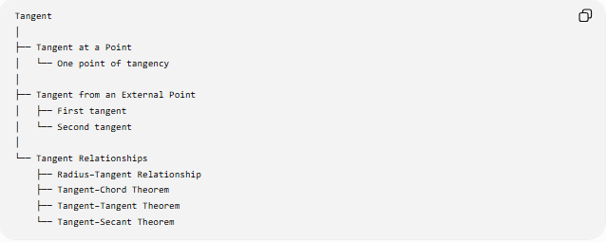
Tangent
│
├── Tangent at a Point
│ └── One point of tangency
│
├── Tangent from an External Point
│ ├── First tangent
│ └── Second tangent
│
└── Tangent Relationships
├── Radius–Tangent Relationship
├── Tangent–Chord Theorem
├── Tangent–Tangent Theorem
└── Tangent–Secant Theorem

Real-World Applications
# Source: AI Source: Provided by: [Data Path: Persons Table -> ID Column: 1, Name_En Column: Motasem Essam] -> From: [ChatGPT] on [7/25/2026]
Tangents are used in:
- Wheel and road geometry
- Circular mechanical parts
- Gears and rotating machinery
- Engineering design
- Architecture
- Computer graphics
- CAD systems
- Optics and reflective surfaces
- Navigation and trajectory calculations

Key Points
# Source: AI Source: Provided by: [Data Path: Persons Table -> ID Column: 1, Name_En Column: Motasem Essam] -> From: [ChatGPT] on [7/25/2026]
- A tangent is a line that intersects a circle at exactly one point.
- The intersection point is called the point of tangency.
- The radius to the point of tangency is perpendicular to the tangent:
$$\boxed{OA⊥l}$$
- A point inside a circle has no tangent.
- A point on a circle has one tangent.
- A point outside a circle has two tangents.
- Tangent segments from the same external point are equal.
- The tangent–chord theorem connects tangent angles with inscribed angles.
- The tangent–secant theorem connects tangent and secant lengths.

Conclusion
# Source: AI Source: Provided by: [Data Path: Persons Table -> ID Column: 1, Name_En Column: Motasem Essam] -> From: [ChatGPT] on [7/25/2026]
A Tangent is a line that touches a circle at exactly one point. Its defining geometric property is the perpendicular relationship between the tangent and the radius drawn to the point of tangency. Tangents are closely connected to radii, chords, secants, inscribed angles, and external points, making them an important fundamental concept in circle geometry.

